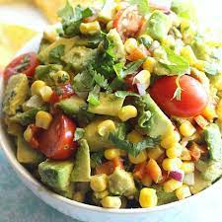
Chipotle, Corn,
& Avocado Salad
Ingredients
- 2 cans of corn, thawed
- 1 can (15 ounce) black beans, rinsed and drained
- 1 small red pepper, chopped
- 5 green onions, chopped
- 2 Avocados, chopped
- ¼ cup vegetable oil
- 2 tablespoons fresh lime juice
- 1 tablespoon red wine vinegar
- 2 chipotle peppers, finely chopped
- 2 cloves garlic, minced
- 2 tablespoons fresh chopped cilantro
- ½ teaspoon cumin
- ½ teaspoon salt
- ¼ teaspoon pepper
Instructions
- In a large bowl mix the corn, black beans, red pepper and green onions.
- Gently mix in the chopped avocado.
- In a small bowl whisk together the vegetable oil, lime juice, red wine vinegar, Chipotle peppers, garlic, cilantro, cumin, salt and pepper.
- Pour over the corn salad and gently mix.
- Cook's Notes: To chop Avocado: Slice avocado lengthwise in half and remove the pit. Leave in the shell, take a knife and slice down the avocado, and then across in a criss-cross pattern. Take a spoon and gently scoop cubed pieces into your bowl.

Pineapple Salsa

Ingredients
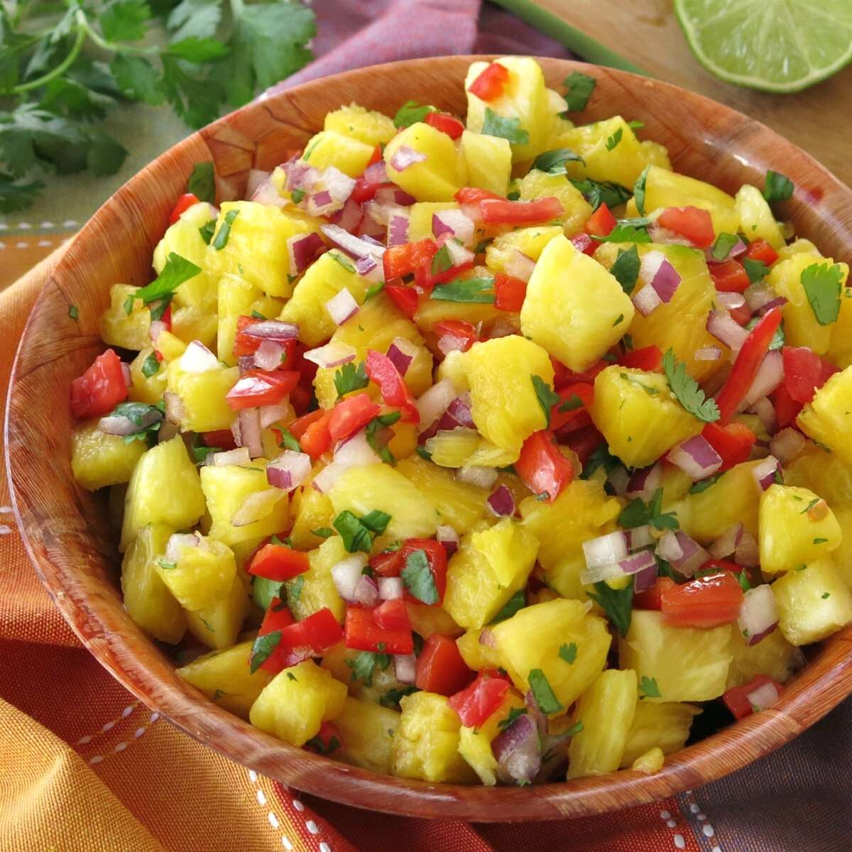
- Whole pineapple,
- 1 cup diced pineapple
- 1 cup diced bell peppers, (any combination of red, orange, yellow or green peppers)
- 1 cup diced tomatoes
- 1/3 cup chopped cilantro
- 1/4 cup minced red onion
- 4 tbsp lime juice,
- 1/4 tsp black pepper
- 1/8 tsp salt

Instructions
- To make the pineapple bowl, cut about 1/3 of the pineapple off, leaving the stem attached to the larger piece of the pineapple. Make a cut around the outer edge of the pineapple fruit and make cuts across the middle too. Use a metal spoon to loosen and scoop out the pineapple chunks. Pour the extra juice out of the pineapple bowl so that it is empty.
- Dice enough of the pineapple chunks to make one cup of diced pineapple to be used for the salsa and save the rest for another use.
- In a small bowl, mix together diced pineapple, diced tomatoes, diced peppers, minced onions, chopped cilantro, lime juice, salt, and pepper.
- Transfer the salsa to the pineapple bowl for serving.
- Store in the fridge.

